**Advance Web Engineering**

**Component-2 Documentation**

**Diwash Bhatta**

**77297903**

**Development Choice:**

PHPStorm (2023.2.4) -> for Laravel backend

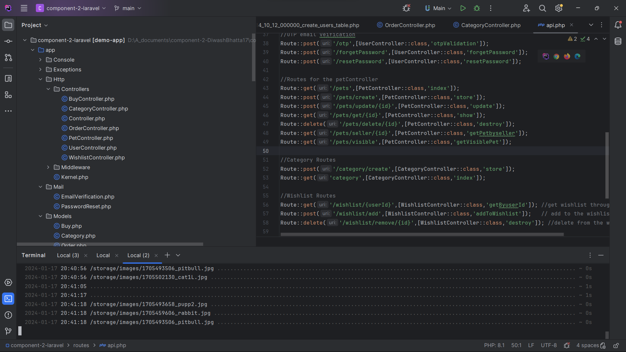

**Visual Studio Code -> As a react Frontend**

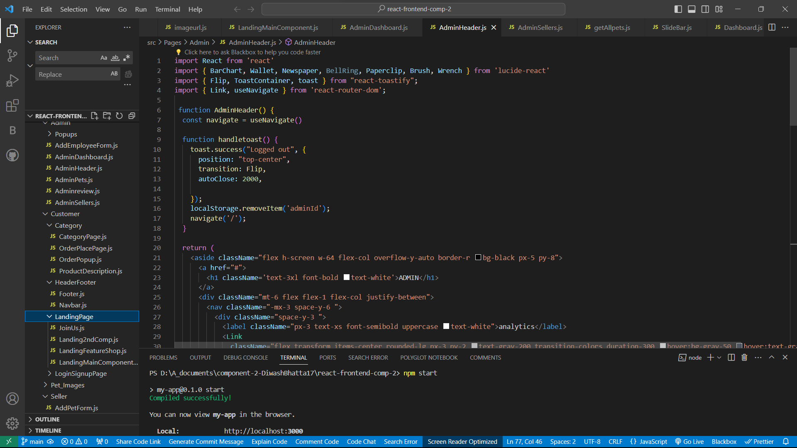

**PHP Version being used: 8.1.24**

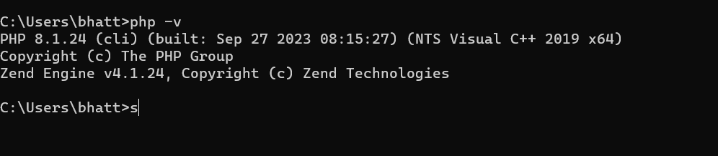

**Github Accounts**

Github TBC: <https://github.com/tbc-bsc-l6/component-2-DiwashBhatta17.git>

Github University: <https://github.com/comp-bkt/component-2-DiwashBhatta17.git>

There is total a 37 commits in both

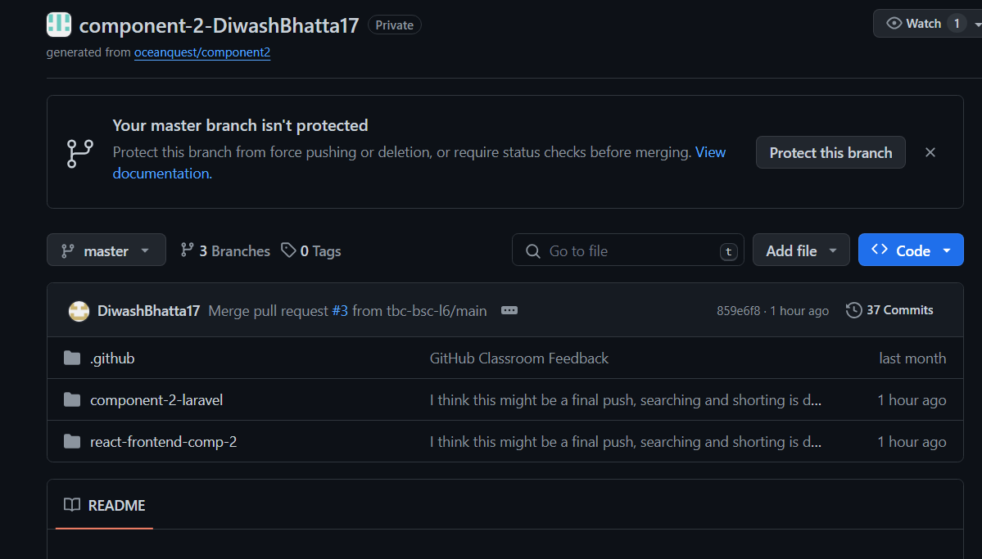

**ScreenShot of the landing pages**

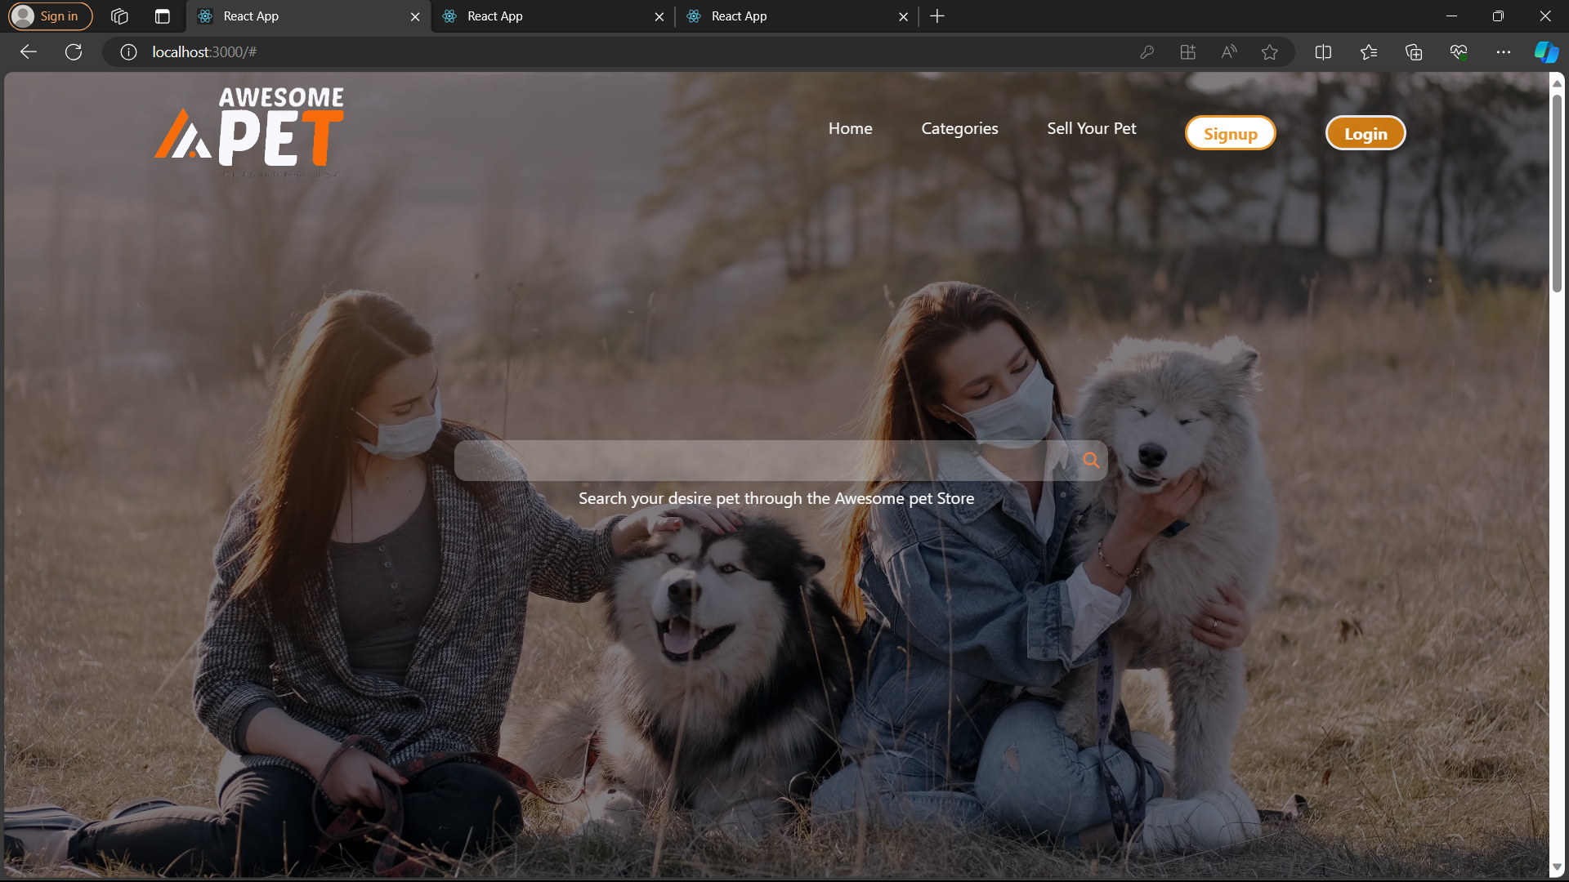

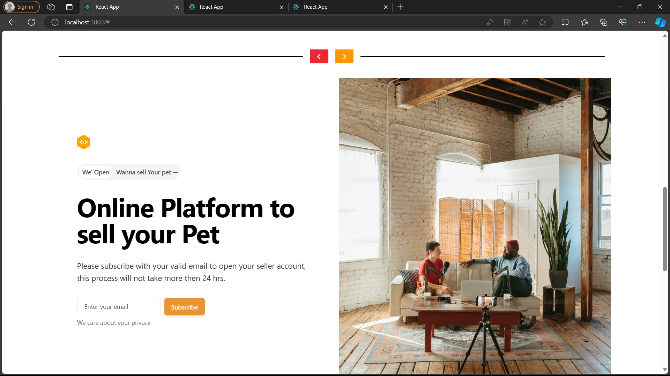

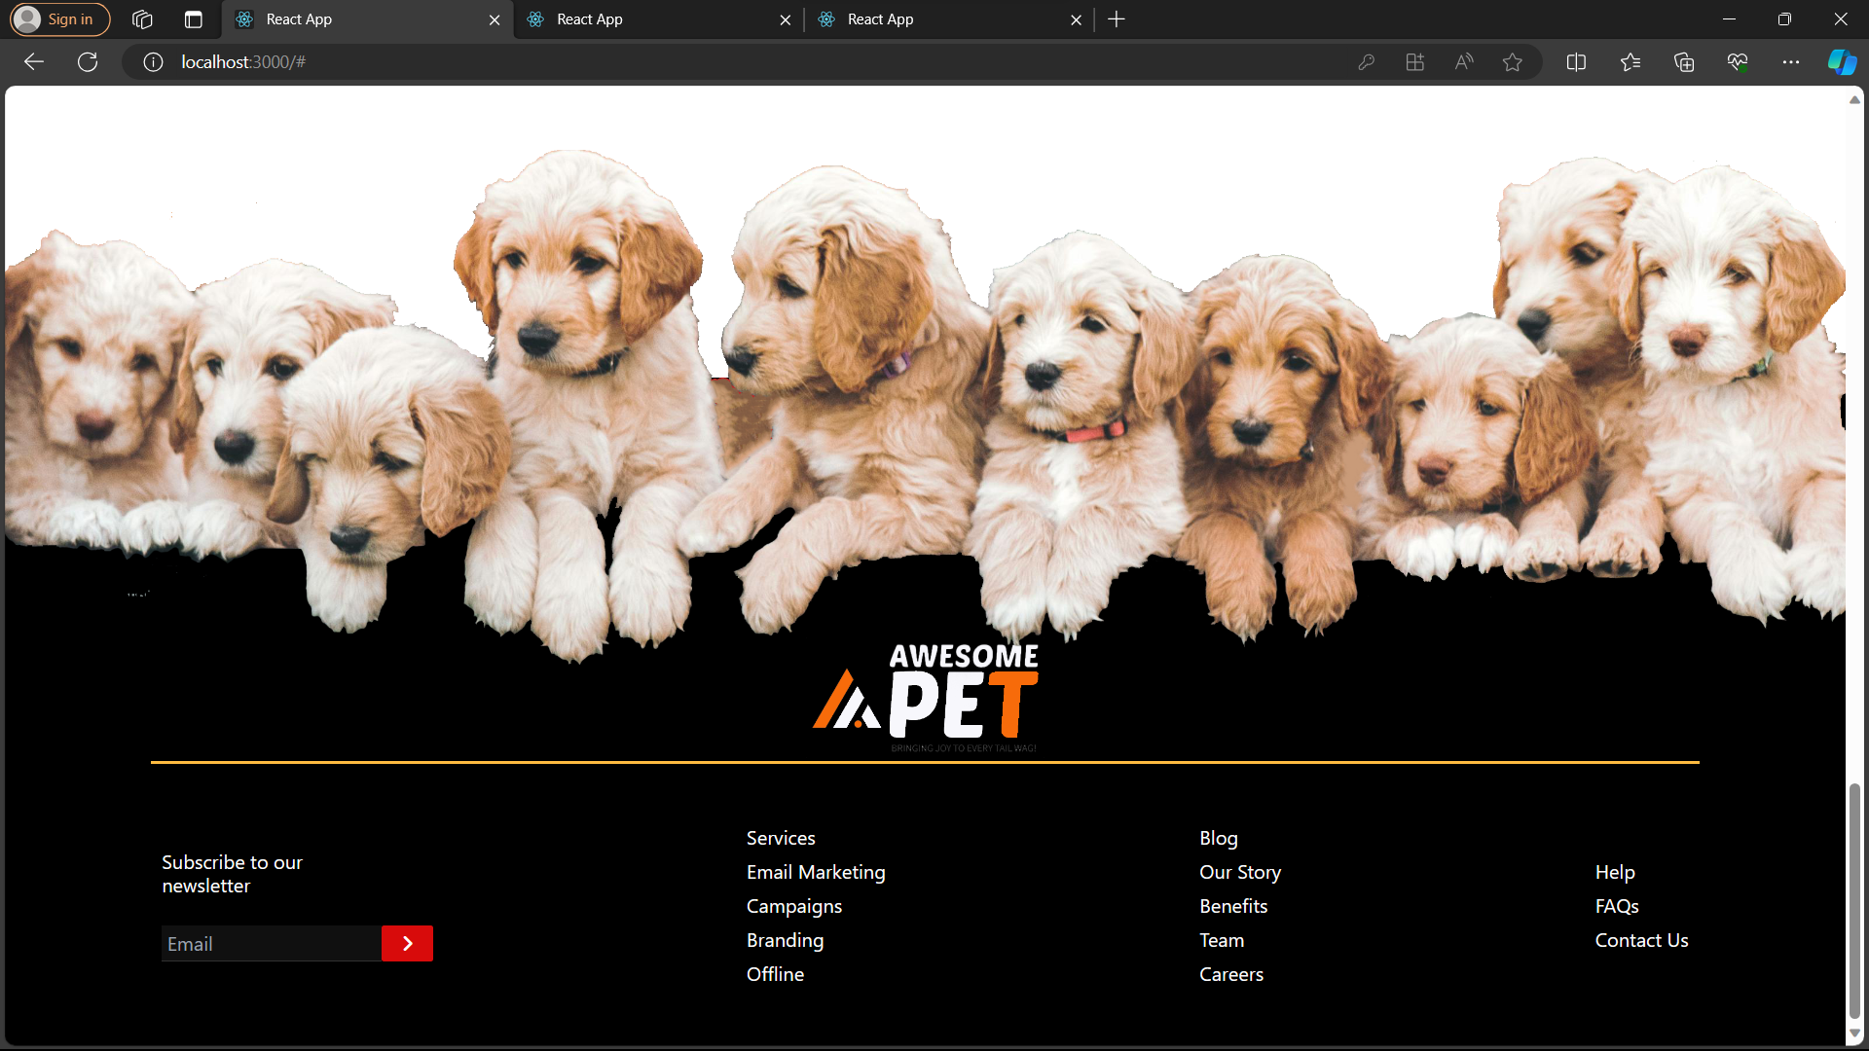

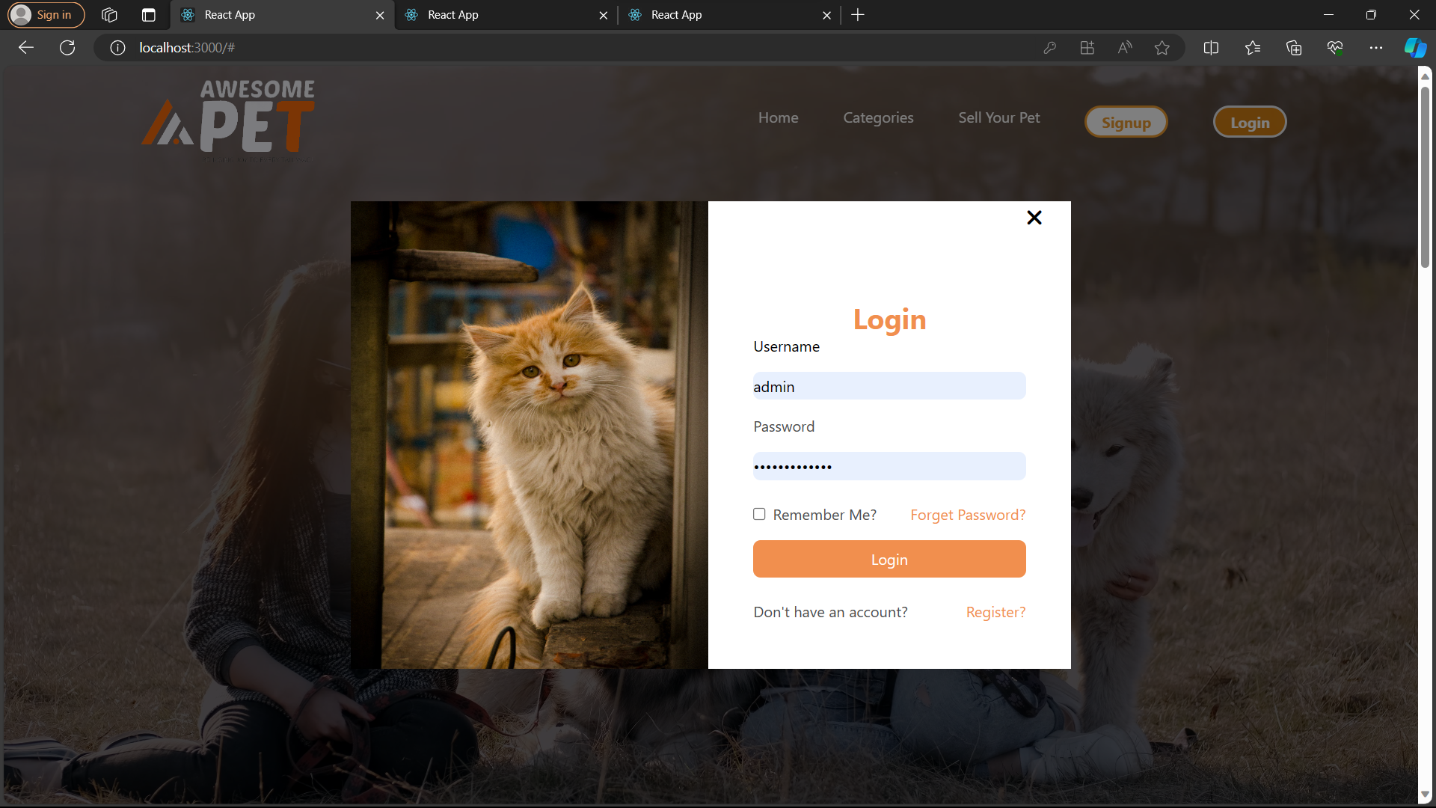

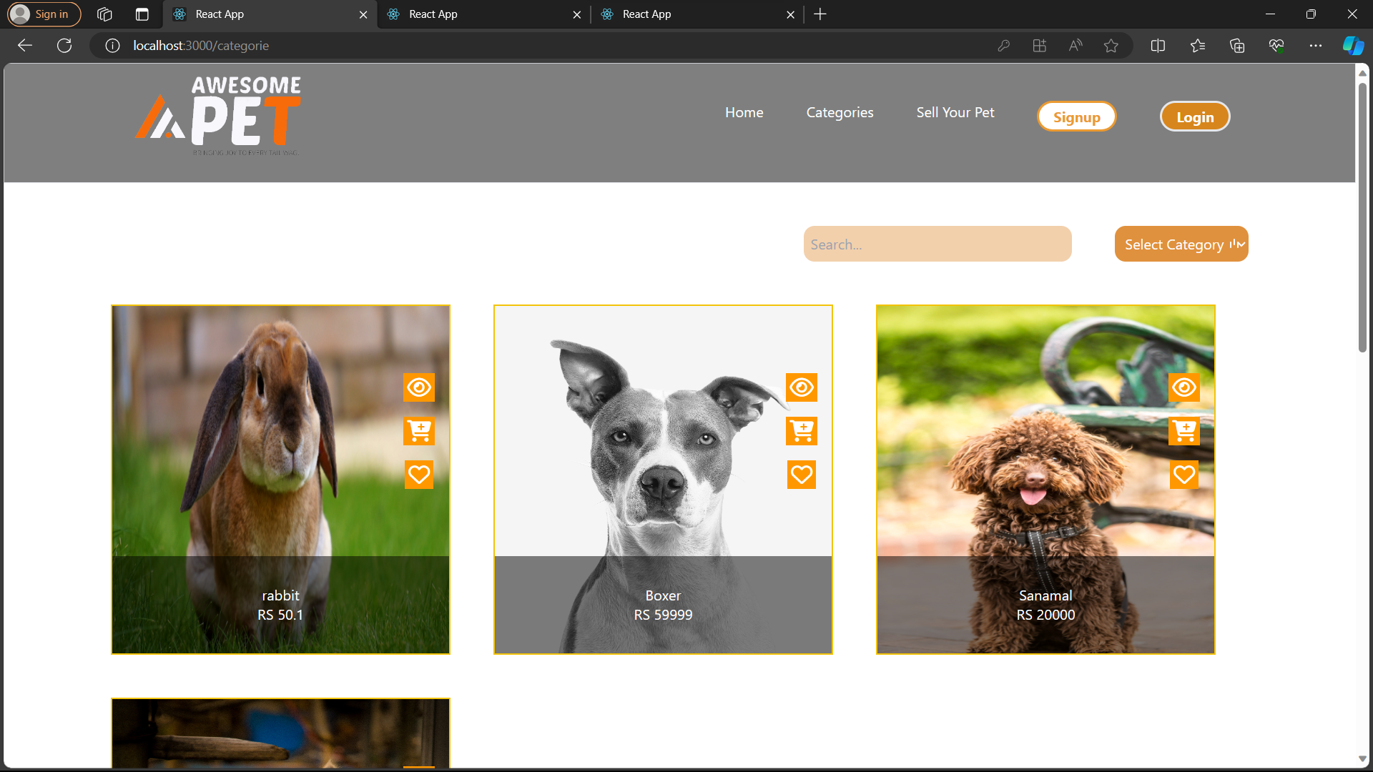

**Seller Sides:**

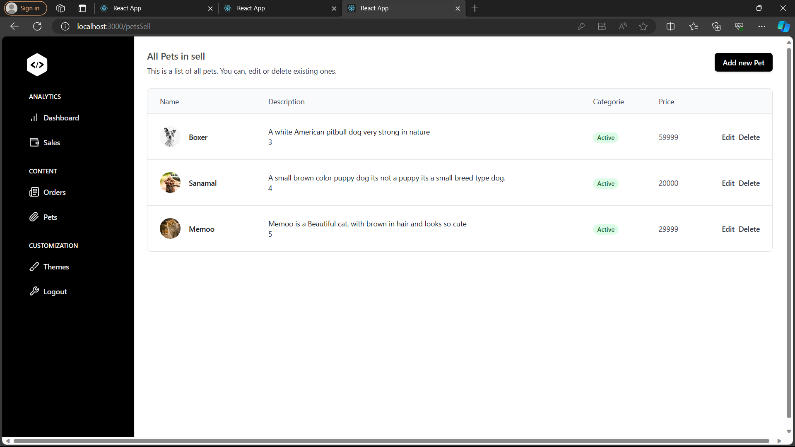

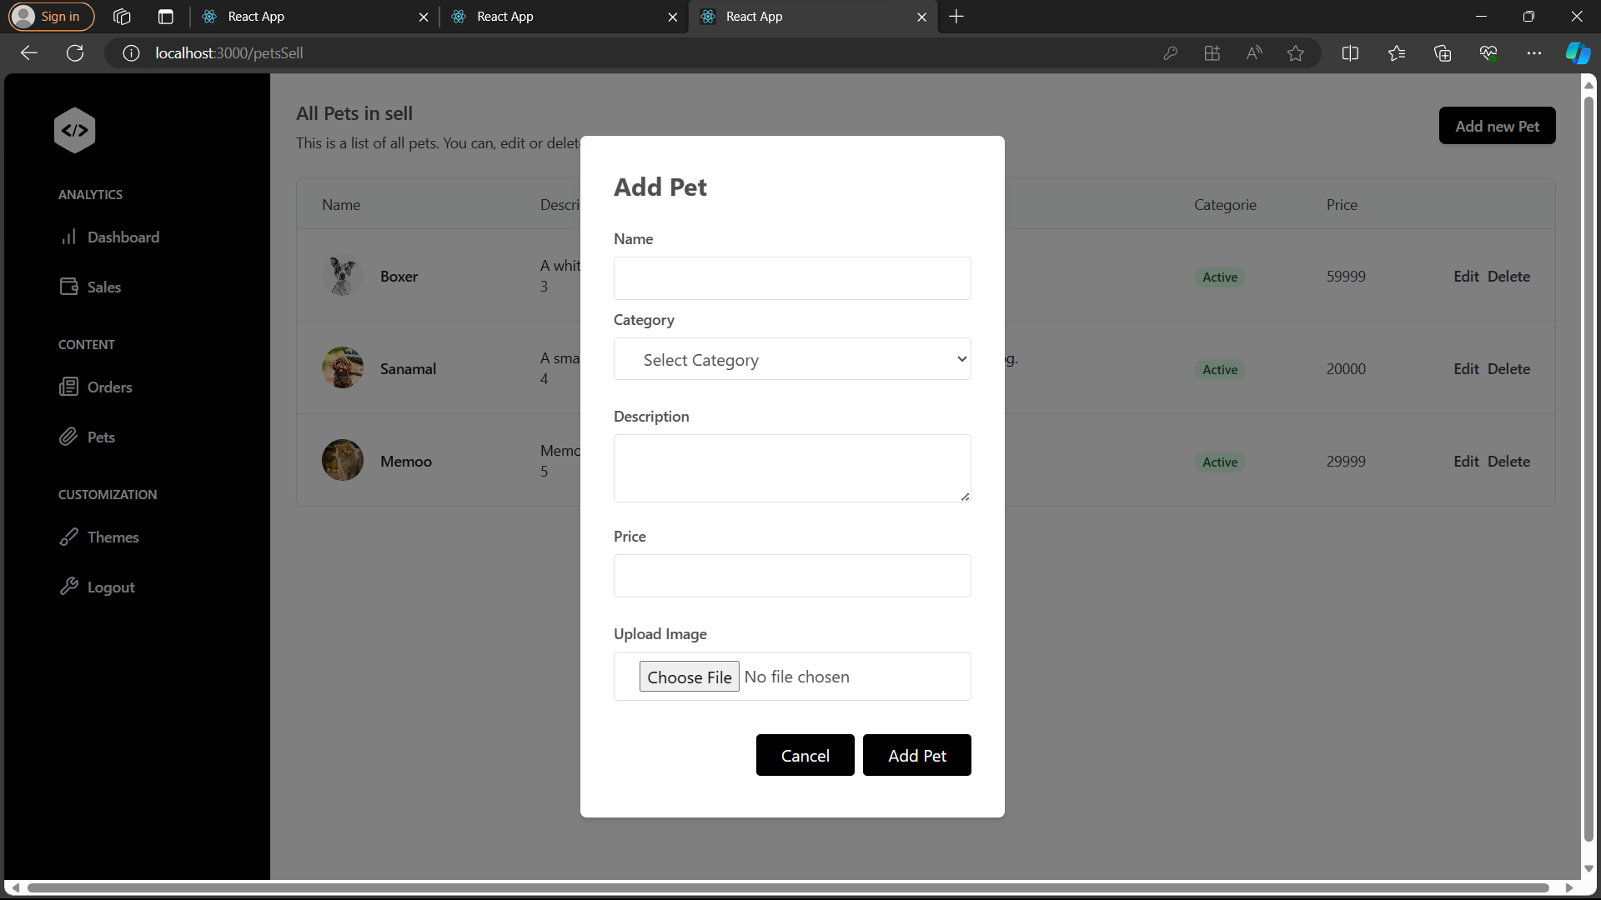

**AdminSide:**

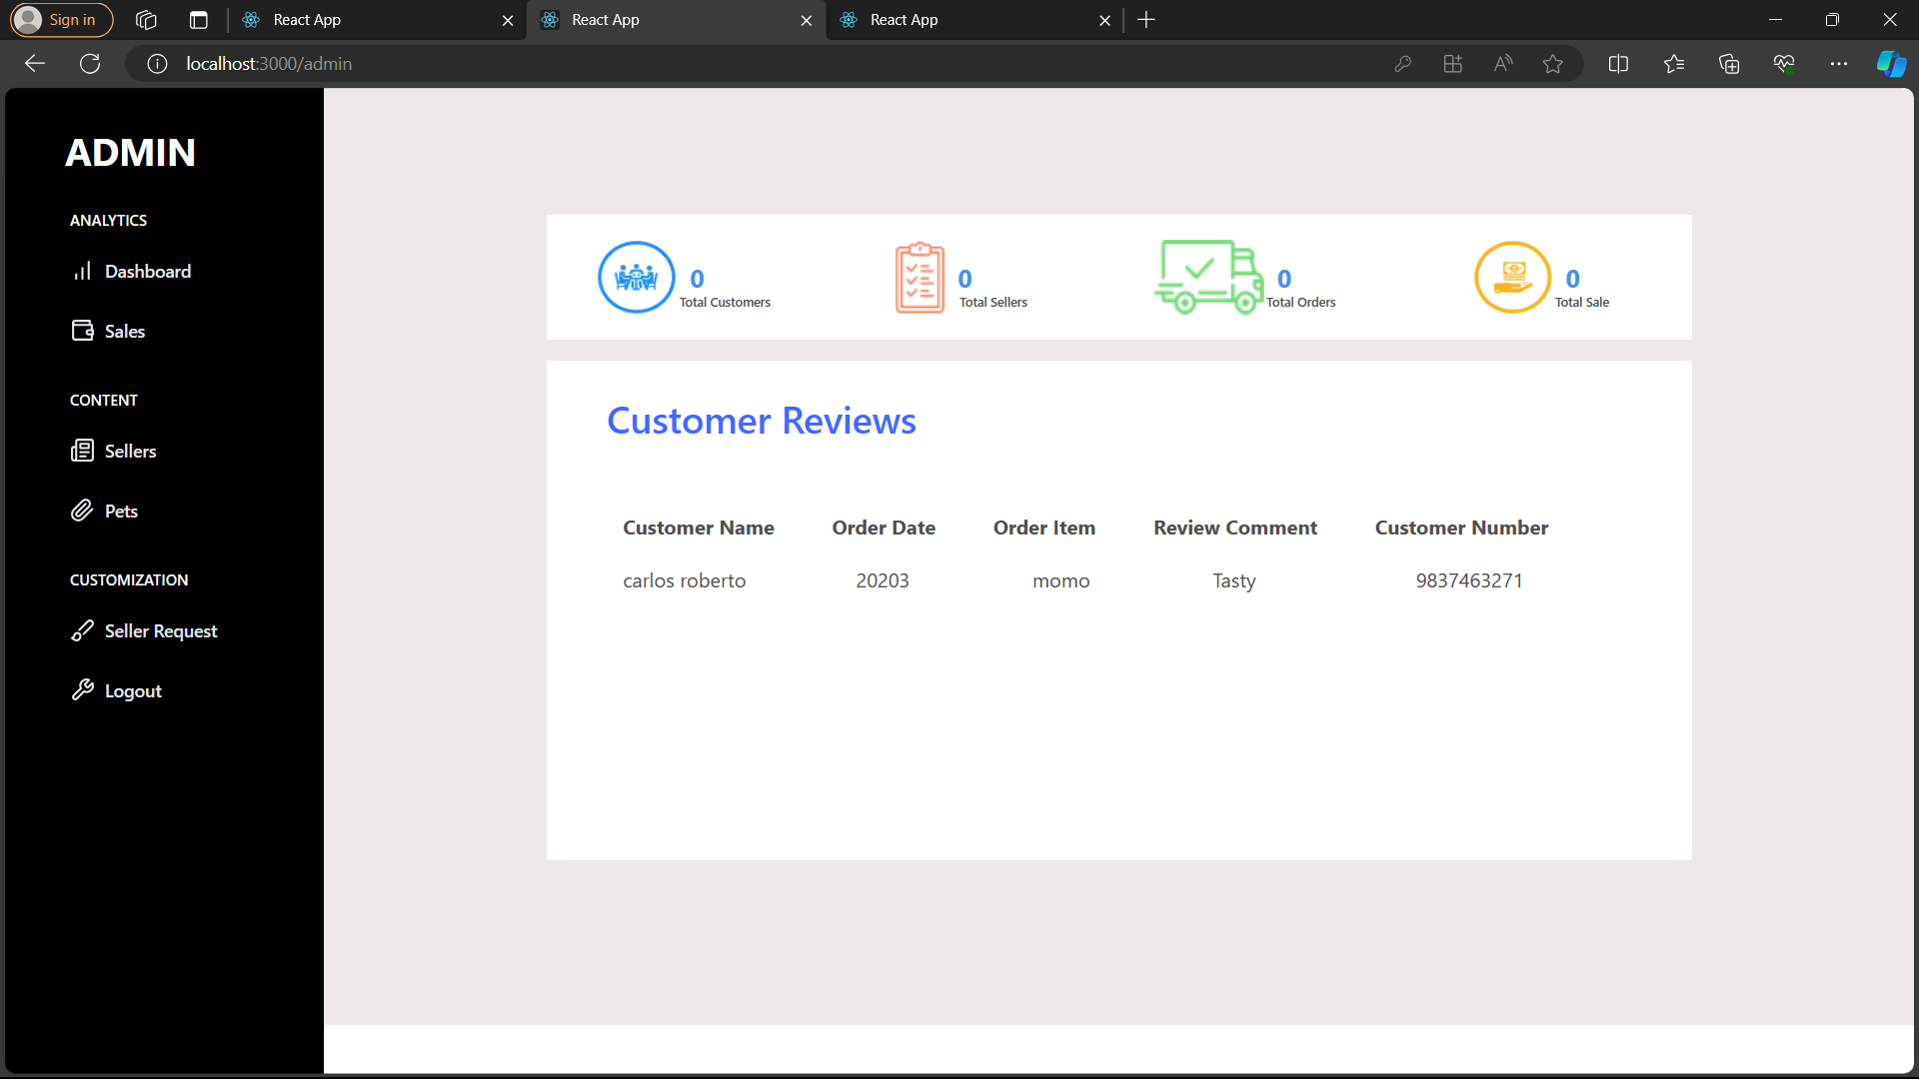

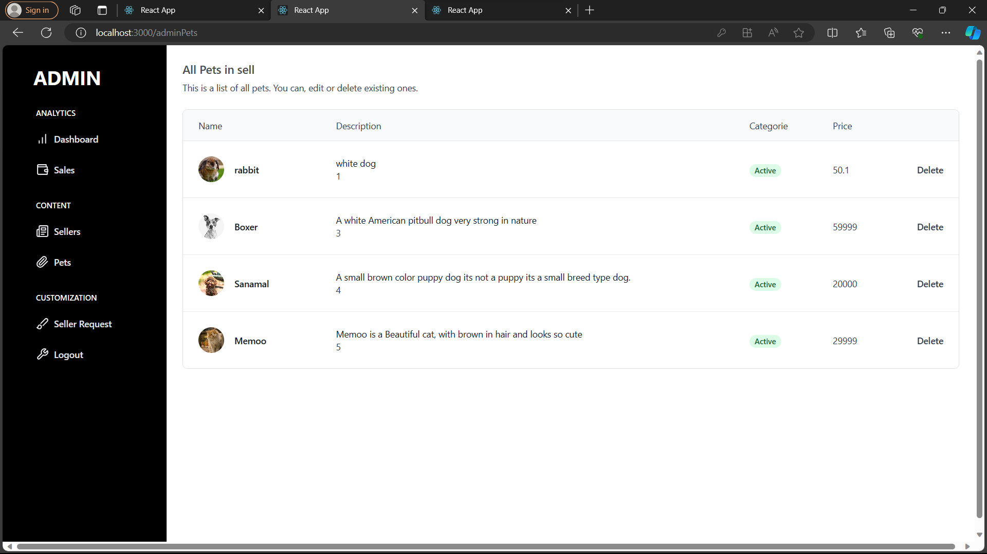

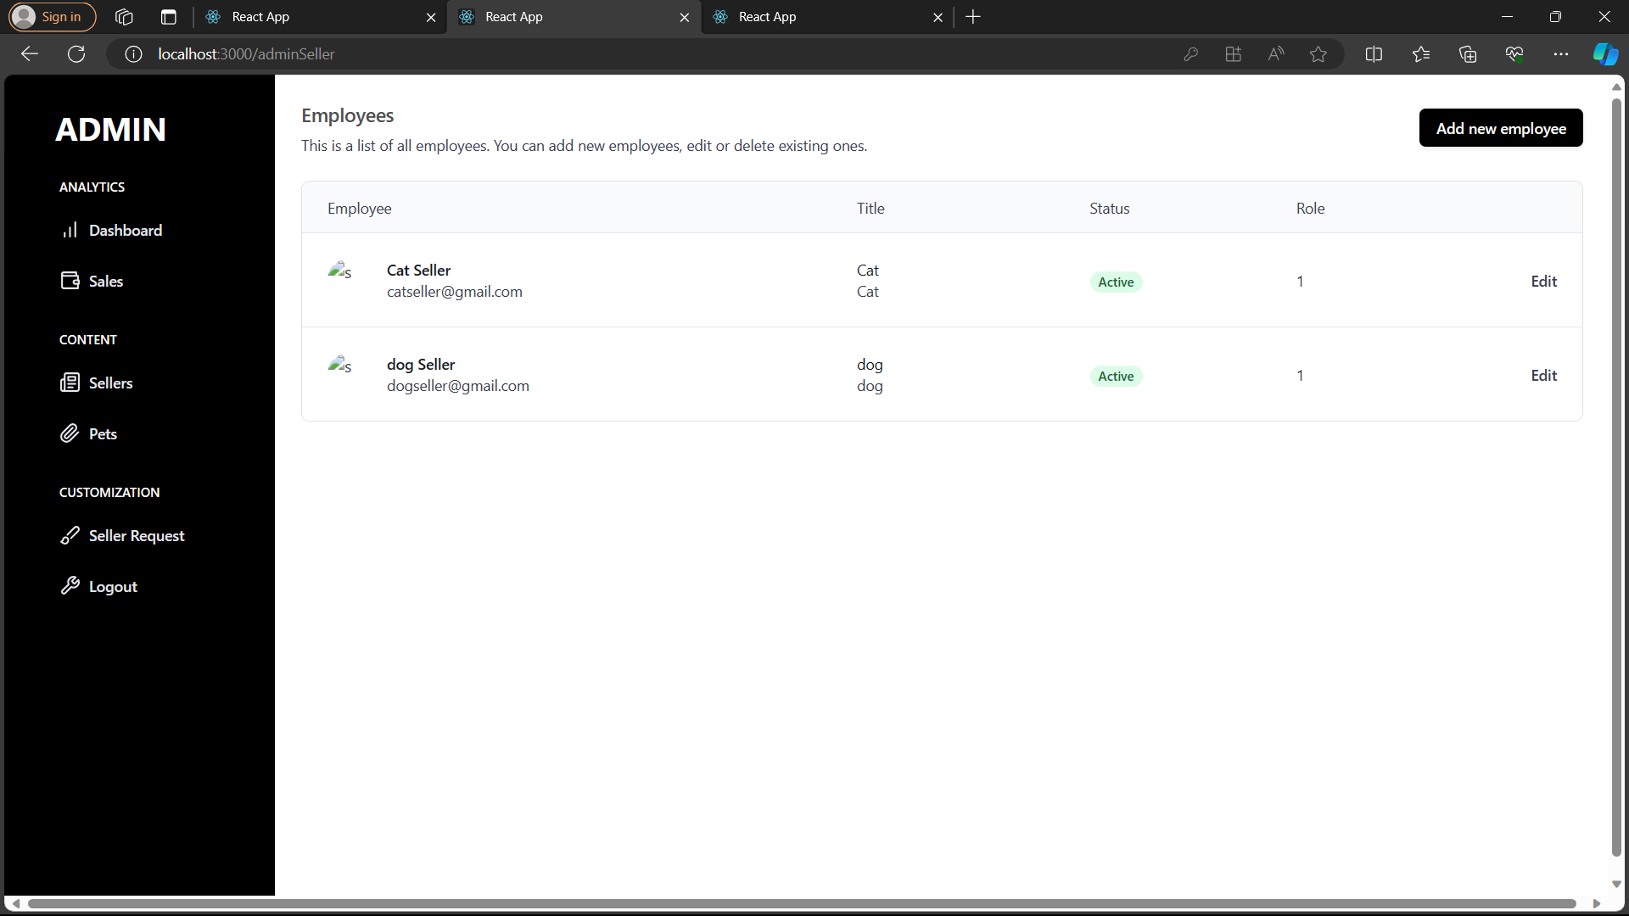

**Some Backend Code Reviews**

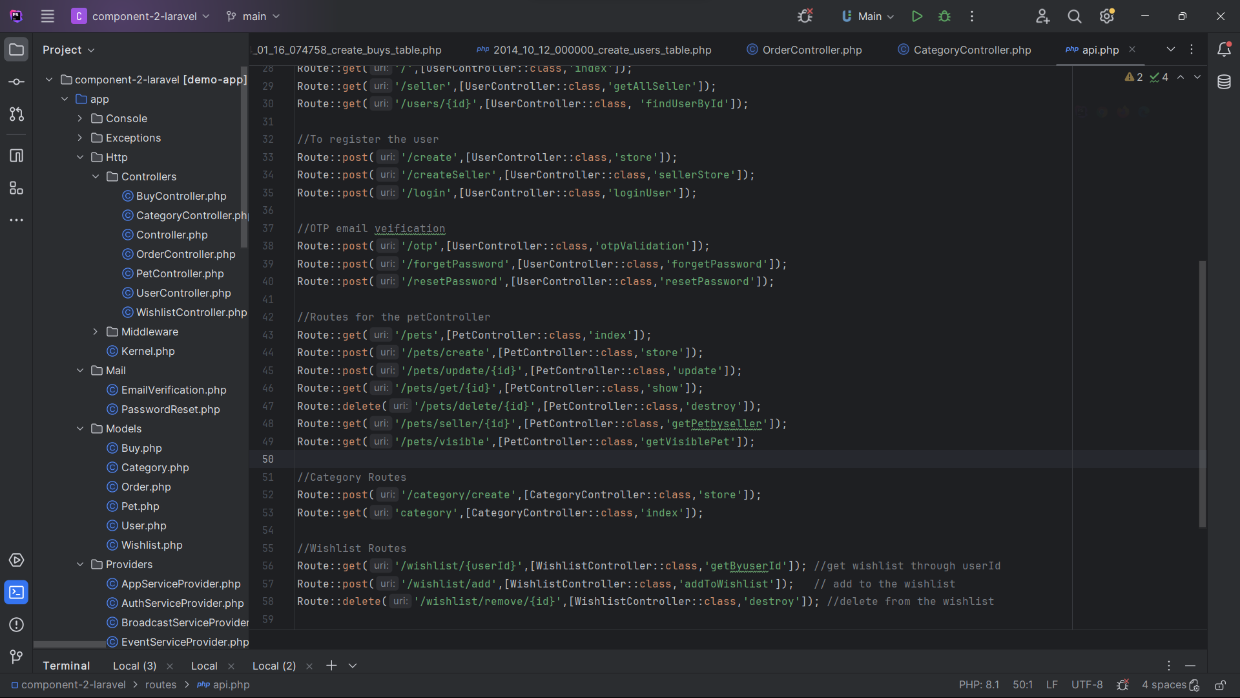

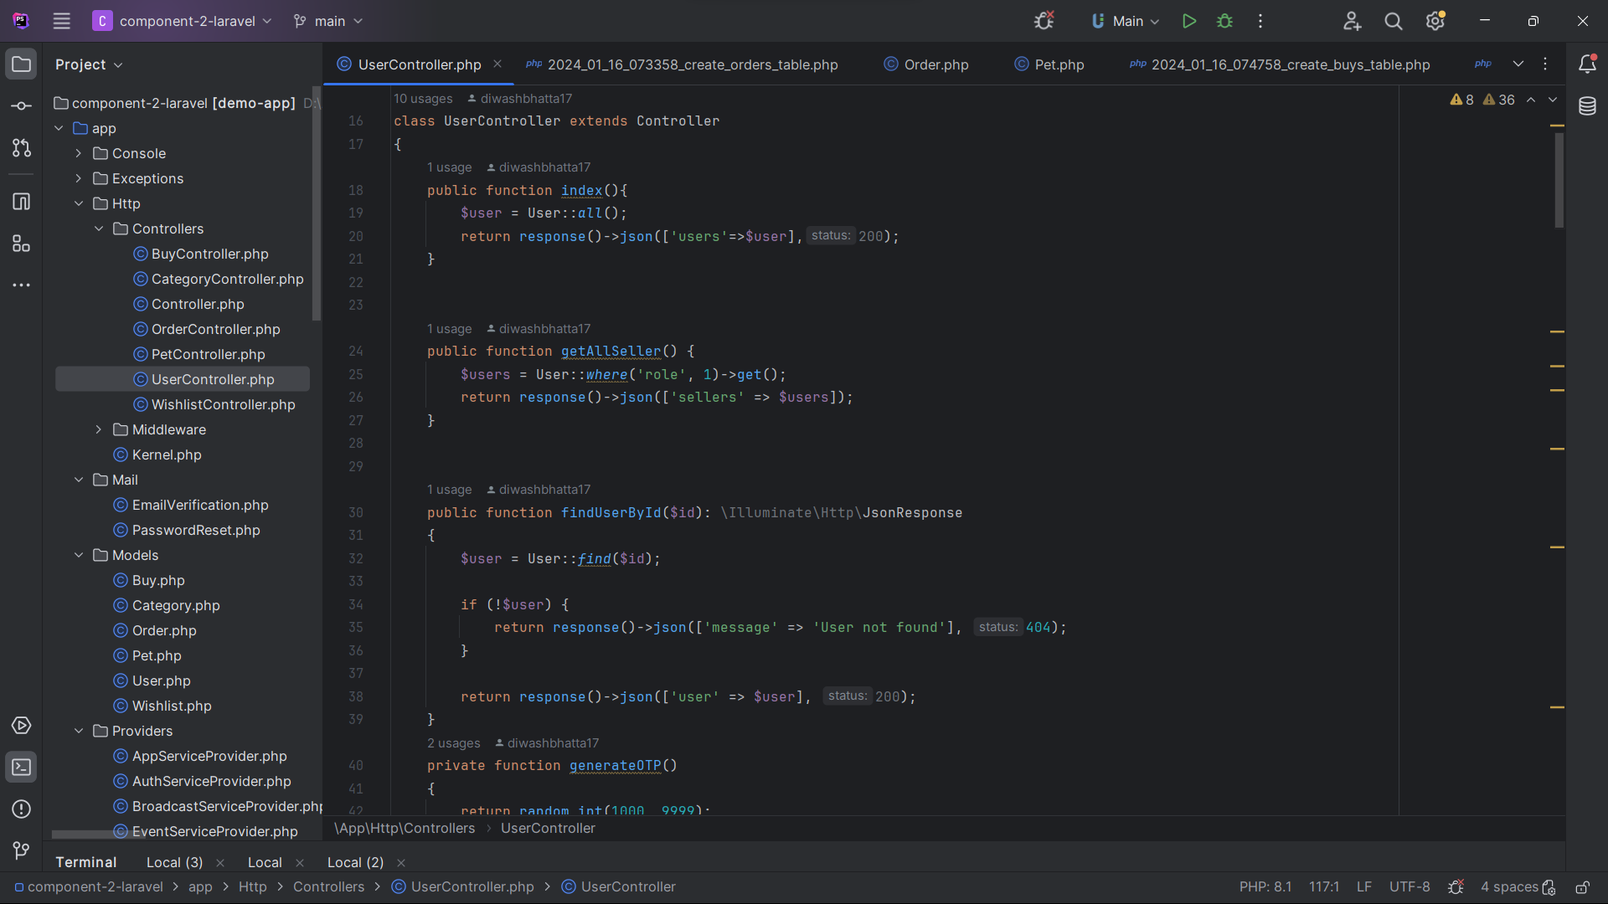

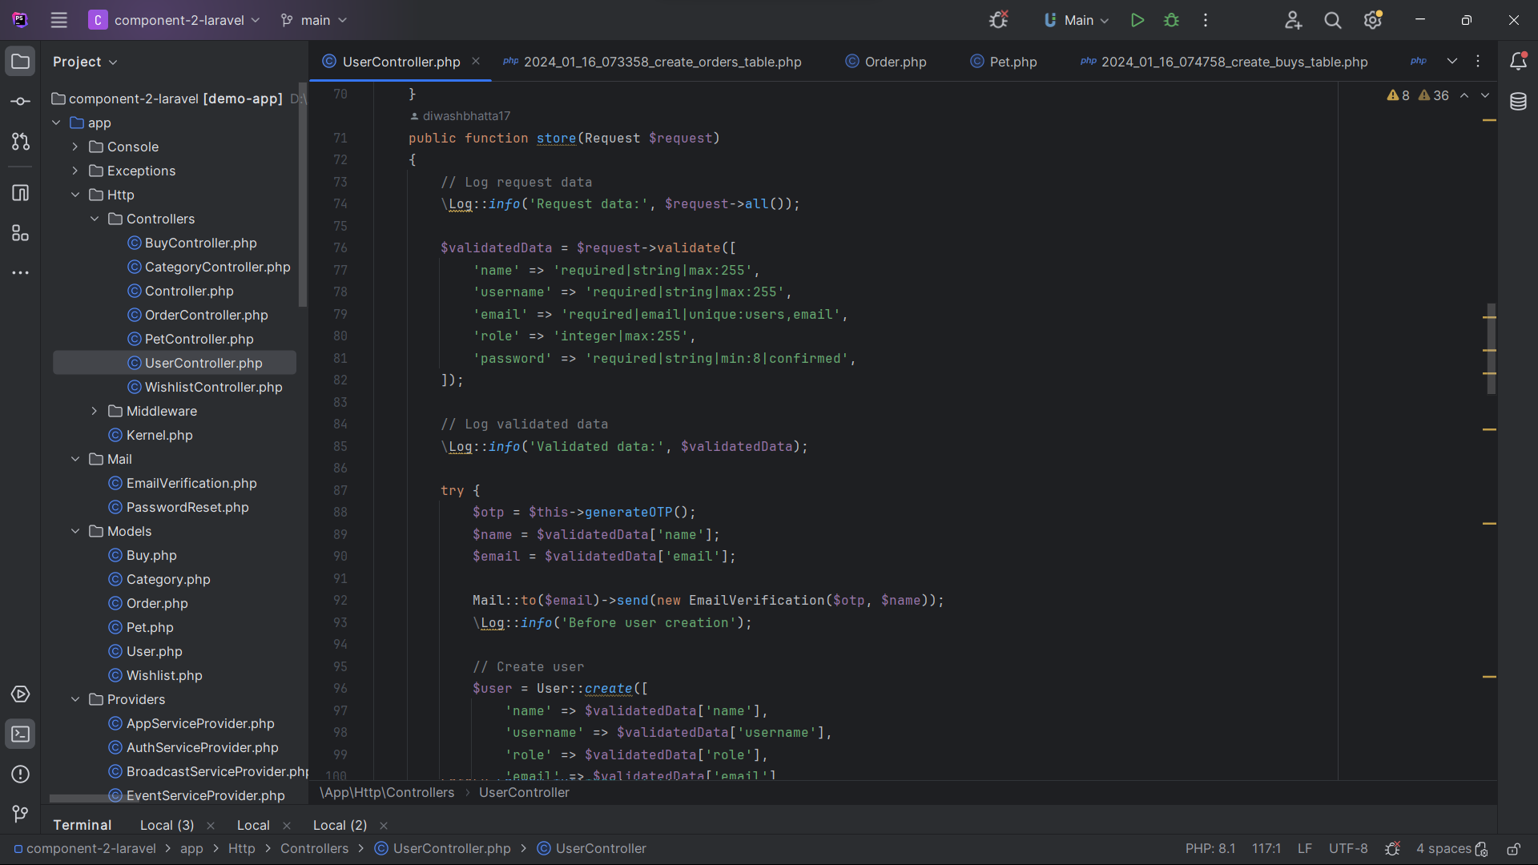

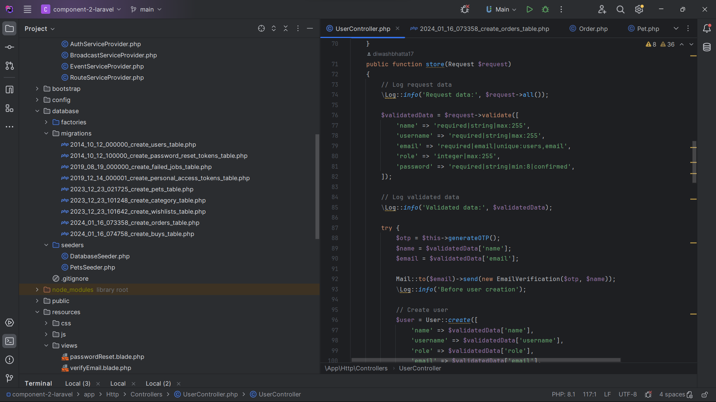

**Use PostgreSQL as Database**

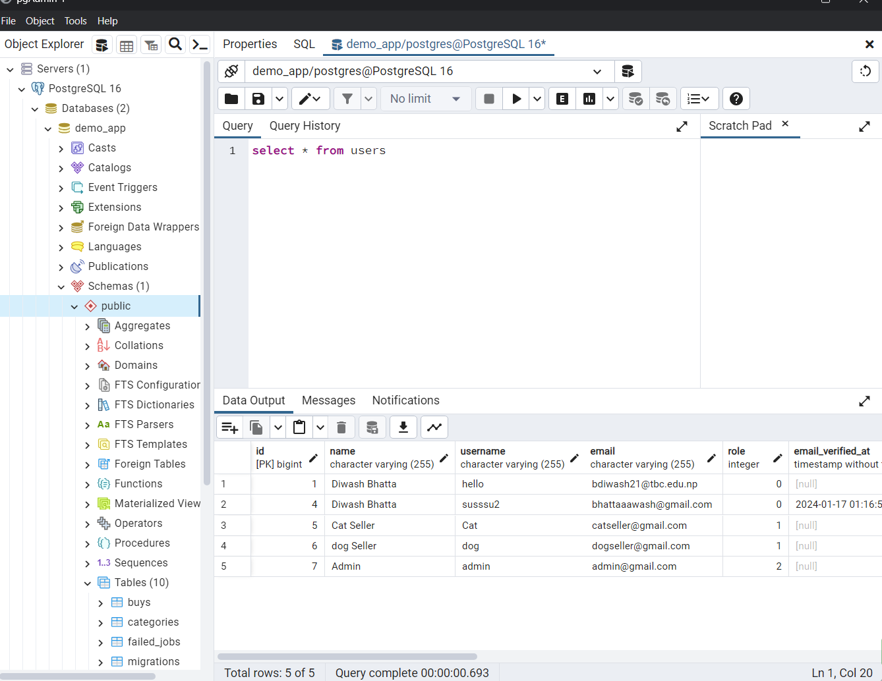

**Postman As a API tester**

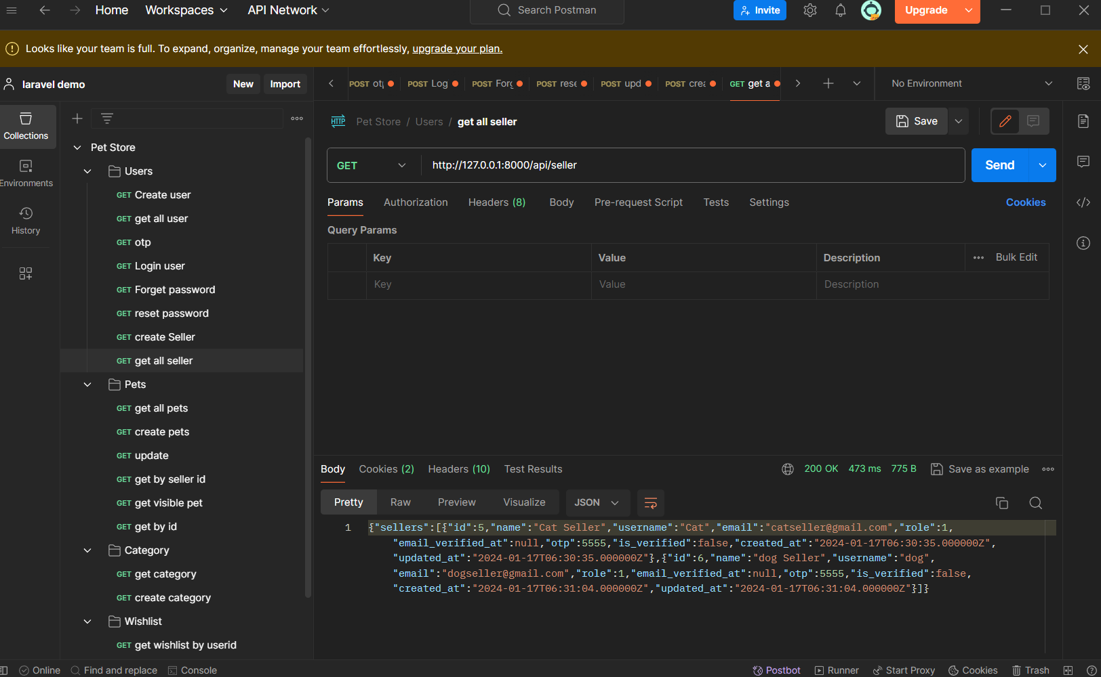

**ThankYou**